MTF Clean Cooking Stove Analysis

Descriptive Statistics
- Households with Clean cooking Stove
Have clean cooking stove | Count of HH | 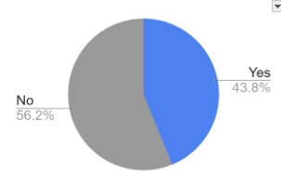
Yes | 2500
No | 3206
Total | 5706

- Household cooking stove type
Cook stove type | Household | 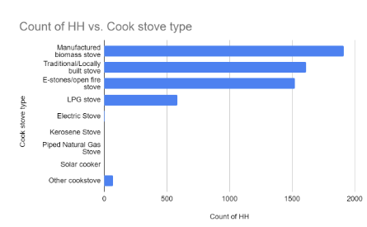
Manufactured biomass stove | 1910
Traditional/Locally built stove | 1612
E-stones/open fire stove | 1523
LPG stove | 585
Electric Stove | 5
Kerosene Stove | 1
Piped Natural Gas Stove | 0
Solar cooker | 0
Other cookstove | 70

Regression Analysis

Clean cooking and electricity
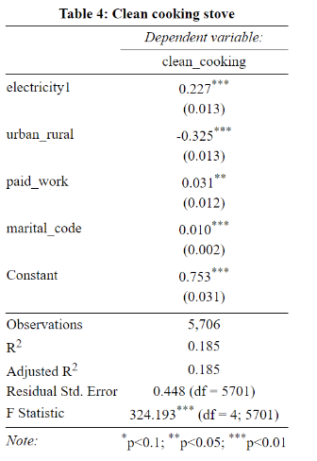
Connection to electricity is positively related to a household owning a clean cooking stove. Households are 22.7% more likely to have a clean cooking stove. This is statistically significant on a 1% level.

Clean cooking related fuel prep time-use regressions

Question in MTF: K2. In a typical day, how many total minutes did you spend doing fuel and stove preparation along with cooking meals (not including fuel acquisition and boiling water)
- clean_cooking: 1 or 0 for if or not the household use clean cooking stoves, list considered clean cooking stove in MTF:
  - Manufactured biomass stove……3
  - LPG stove…….5
  - Piped Natural Gas stove…..6
  - Electric stove…7
  - Solar cooker…8
- solar: 1 or 0 for if or not the household use solar energy
- electricity: 1 or 0 for if or not the household use electricity
- Regressions are run with cluster level fixed effects.

Descriptive statistics on fuel and stove preparation:

Unit: Minutes | Min | 1st Qu. | Median | Mean | 3rd Qu. | Max
Women | 0 | 45 | 60 | 80.85 | 120 | 180
Men | 0 | 0 | 0 | 16.46 | 20 | 120

Controlling for electricity, solar, ubudehe categories
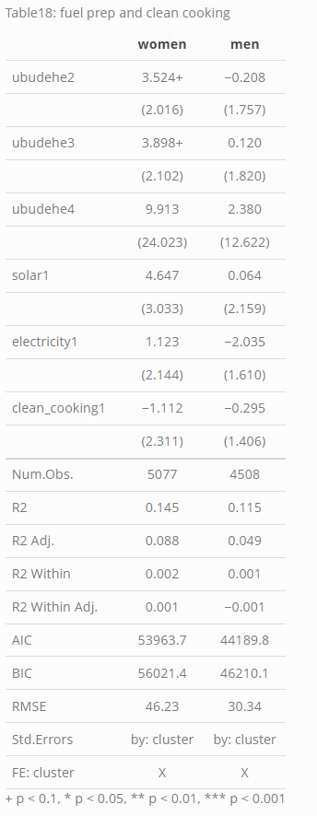
Controlling for ubudehe categories, electricity, and solar connected households, households with clean cooking stoves spend approximately 1.112 minutes less per day in preparing for fuel and cooking than those without clean cooking stoves. This is not statistically significant.

Separately for each factor(clean_cooking, electricity, solar)
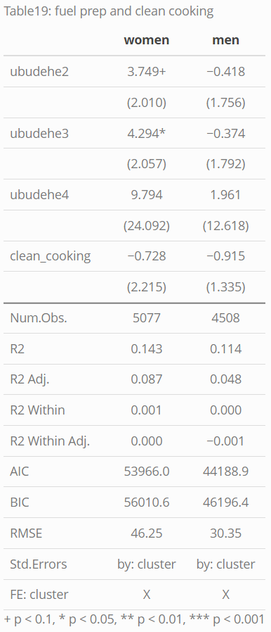
Controlling for ubudehe categories, households with clean cooking stoves spend approximately 0.728 minutes less per day in preparing for fuel and cooking than those without clean cooking stoves. This is not statistically significant.
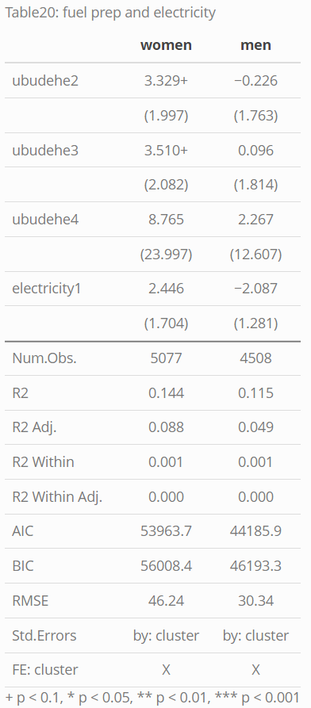
Controlling for ubudehe categories, households with grid electricity spend approximately 2.446 minutes more per day in preparing for fuel and cooking than those without clean cooking stoves. This is not statistically significant.
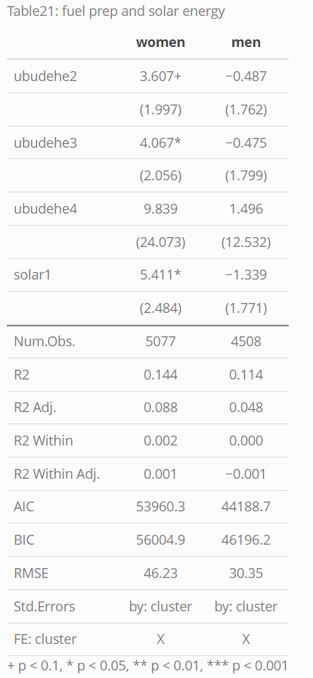
Controlling for ubudehe categories, households connected to solar energy spend approximately 5.411 more minutes less per day in preparing for fuel and cooking than those without clean cooking stoves. This is statistically significant on a 10% level.

